**Activities to Build ENGAGEMENT**

* Back-to-School Night
* Family Engagement Activities
* Open House
* After School Program Opportunities
* Multi-Tiered Systems of Support-Academics (MTSS-A)
* Multi-Tiered Systems of Support-Behavior

(MTSS-B)

* Second Step Curriculum
* Parent Teacher Association (PTA) Events
* Parent Workshops
* Positive Behavior Interventions and Supports (PBIS) Committee
* School Site Council, English Learner’s Advisory Committee, Gifted and Talented Education District Advisory Committee, Partnerships for Learning Network (PFLN)

**Volunteering Opportunities**

If you would like to volunteer, please visit the office or contact the classroom teacher.

**Chino Valley Unified**

**School District**

**What is a Home-School Partnership?**

Home-School Partnerships is an agreement that parents, students and teachers develop together. It explains how parents and teachers will work together to make sure all students reach or exceed grade-level standards.

Effective compacts:

* **Link** to goals of the school's single plan for student achievement
* **Focus** on student learning skills
* **Describe** how teachers will help students develop those skills using high-quality curriculum and effective instruction in a supportive learning environment
* **Share** strategies parents can use at home
* **Explain** how teachers and parents will communicate about student progress
* **Describe** opportunities for parents to volunteer, observe, and participate in the classroom

**PARTNERSHIPS FAMILY PARTICIPATION**

**HOME-SCHOOL PARTNERSHIPS**

**for**

**STUDENT ACHIEVEMENT**

**2025-2026**

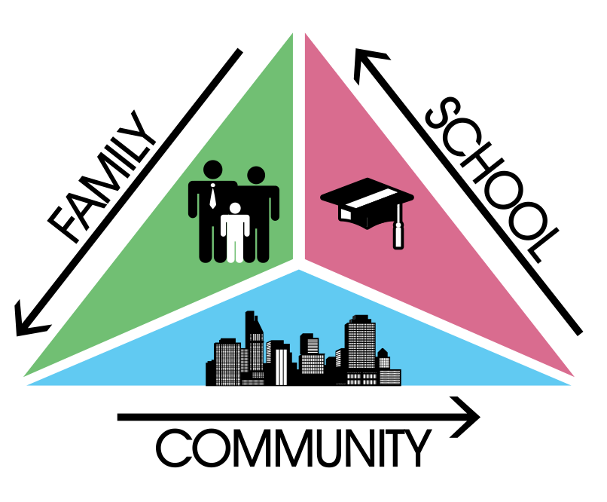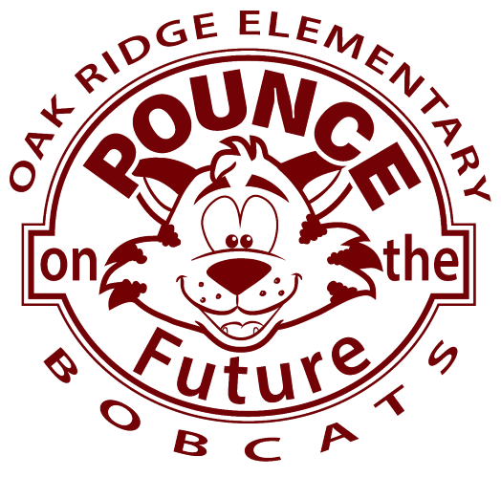

***3rd Grade***

***Always walk through life as if you have something new to learn and you will.***

***Vernon Howard***

**Oak Ridge Elementary**

15452 Valle Vista Drive

Chino Hills, CA 91709

(909) 591-1239

**Learning Compact**

**Communication about Student Learning**

Our school and families are committed to regular two-way communication about our children’s' learning. Some of the ways families and staff communicate all year are:

* **School to Home**
  + PAW Print Newsletter
  + Oak Ridge Website
  + Oak Ridge Marquee
  + Aeries Communication/Parent Square
  + Weekly/Daily Folders/Agendas
* **Home to School**
  + Participate in “Activities to build Engagement” (See above)
  + Email and communication applications
  + Parent/Guardian-Teacher Meetings
  + Request for Support form online

*https://www.chino.k12.ca.us/Oakridge*

**DISTRICT PARENT RESOURCES**

**Family Engagement Center**

**Adult School, Room 25**

**12970 Third St. Chino, CA 91710**

***WORKSHOPS PROVIDED:***

***EL PARENT ACADEMY***

***12 POWERS OF FAMILY BUSINESS***

***PARENTS AS PARTNERS***

***TRANSITIONS TO…..***

***COMPUTER LITERACY***

***FAMILY LITERACY PROJECT-COLLEGE AWARENESS***

**Family Engagement Center Link:**

**http://www.chino.k12.ca.us/Page/8882**

**909 628-1201 ext. 5601/5604 (Spanish)**

**(Chinese) 909 628-1201 ext. 5602**

**At Home**

**Here are some ideas of how families can support students’ success:**

* Establish a homework routine
* Read to/have your child read daily
* Review your student’s classwork/homework regularly
* Ask your child about the strategies they used in class and use them at home
* Know your student’s friends
* Attend parent conferences/school events
* Keep up to date with school and teacher communication
* Provide a healthy nutrition
* Encourage physical activity
* Limit and monitor electronics
* Notice and praise the growth your student is making
* Reinforce positive behavior and celebrate your child when they earn a “Paw Print”
* Make sure your student is well rested
* Ask your student questions about their day
* Understand the technology your student accesses
* Ensure that your student is at school, on time every day
* Be sure your student can dress themselves independently

**In the Classroom**

**As a teacher, I will engage all students with a vibrant learning climate and high-quality instruction. Listed below are some of the student learning strategies your child will use this year.**

**GOAL 1:**

* Teach grade-level curriculum that is aligned to district essential standards and state standards
* Differentiate learning to meet each student’s needs
* Utilize technology to engage learning
* Analyze data from assessments to make sure students are meeting district essential standards and state standards

**GOAL 2:**

* Communicate with families on student progress and work as a team to best help the student
* Share strategies with parents to use at home so they can work with their child
* Provide opportunities for parents to volunteer and participate in the classroom and campus events

**GOAL 3:**

* Work collectively with our feeder group to accomplish our commitments
* Develop a growth mindset attitude
* Build a foundation for student development
* Provide daily, English Language Development for our English Language Learners

**Learning Compact**

**Teachers, Parents, Students Shared Responsibility for Learning**

**District Goals**

**(Local Control Accountability Plan)**

**GOAL 1:** All students are provided a high-quality teaching and learning environment.

**GOAL 2:** Staff, parents, families, and students are connected and engaged at their school to ensure student success.

**GOAL 3:** All students are prepared for college and career beyond graduation.

**School Goals**

**GOAL 1:** 100% of grade level or department teams will respond with intervention and extension for at least 4 common formative assessments with Tier 1 and Tier 2 instruction, as measured by artifacts showing intervention and extension plans by the end of the 2025-2026 school year. 100% of grade level or department teams will clarify for students the Essential Standards to engage students in understanding what they are learning and how they will know when they have learned it. 100% of grade level of department teams will clarify for students the essential standards to engage students in understanding what they are learning and how they will know when they have learned it, and have students reflect on their learning.

**GOAL 2:** The Tier 2 team will review, in detail, the process for requesting support for a student with staff to increase frequency of use for the 2025-2026 school year. Parent workshops will be offered that focus on student achievement, student wellness, and family literacy. Chronic absenteeism will be monitored monthly and SART/SARB meetings will be held, as appropriate. In addition, attendance incentives will be given to students to encourage 97.5% or higher attendance for each attendance.

**GOAL 3:** On the 2025-26 CAASPP, the percent of students scoring at “standards met” or “Standards Exceeded” will increase by 3% at every grade level in ELA and math.

*Our school provides high quality curriculum and instruction in supportive and effective classroom environments to enable students to meet state academic standards. We support our students and work hard to provide a welcoming, safe school environment.*

**Our Goals for**

**Student Achievement**